Part one

I have created azure storage

After that in the static web pages I needed to enable static webpages

In the input fileds I have added path to index.html

After that in containers menu I have selected $web and open it

In the $web I have uploaded my index.html file.

On this url is my static page <https://markomidterm.z13.web.core.windows.net/>

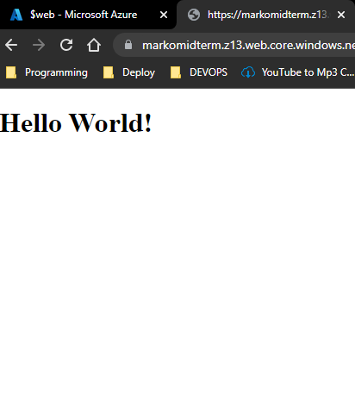

PART 2

I have created new virtual machine from virtual machine menu

After that I have modified network option to allow me only from my local machin to be accessible vie ssh

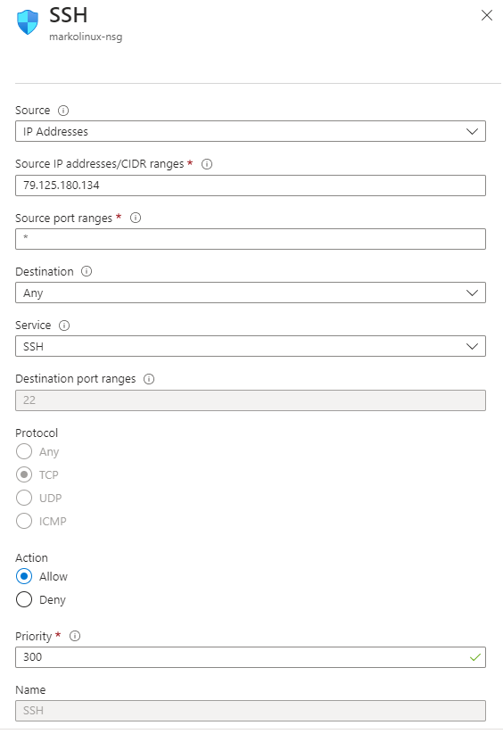

After that I have enabled to be access on browser

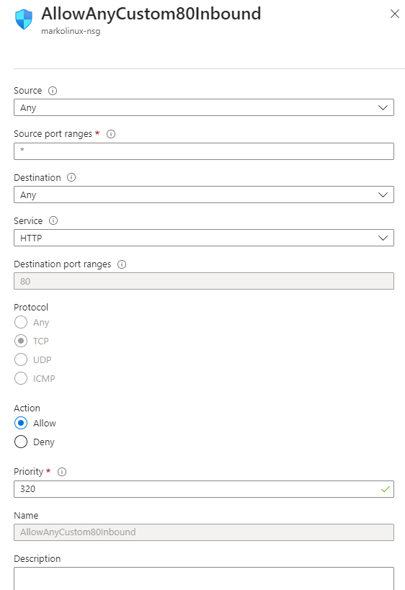

I have installed apache 2 server on my VM

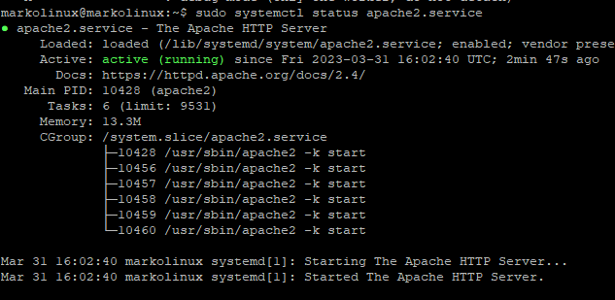

I have created index.html file on the apache server folder

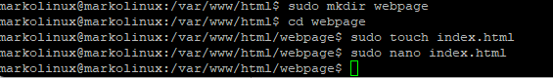

And this is the result from the browser

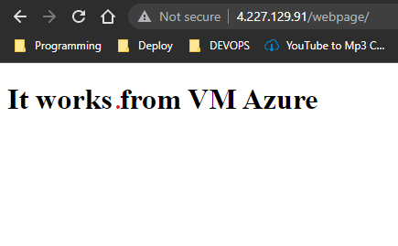

And this is from mobile browser

